Introduction to Programming Assignment
Joy Waititu – 220085
Question 1: Block Statement
public class BlockExample {
public static void main(String[] args) {
// Variable declarations
int studentNumber = 220085;
int number2 = 50;
// Calculate the sum
int sum = studentNumber + number2;
// Output the result
System.out.println("Sum: " + sum);
}
}
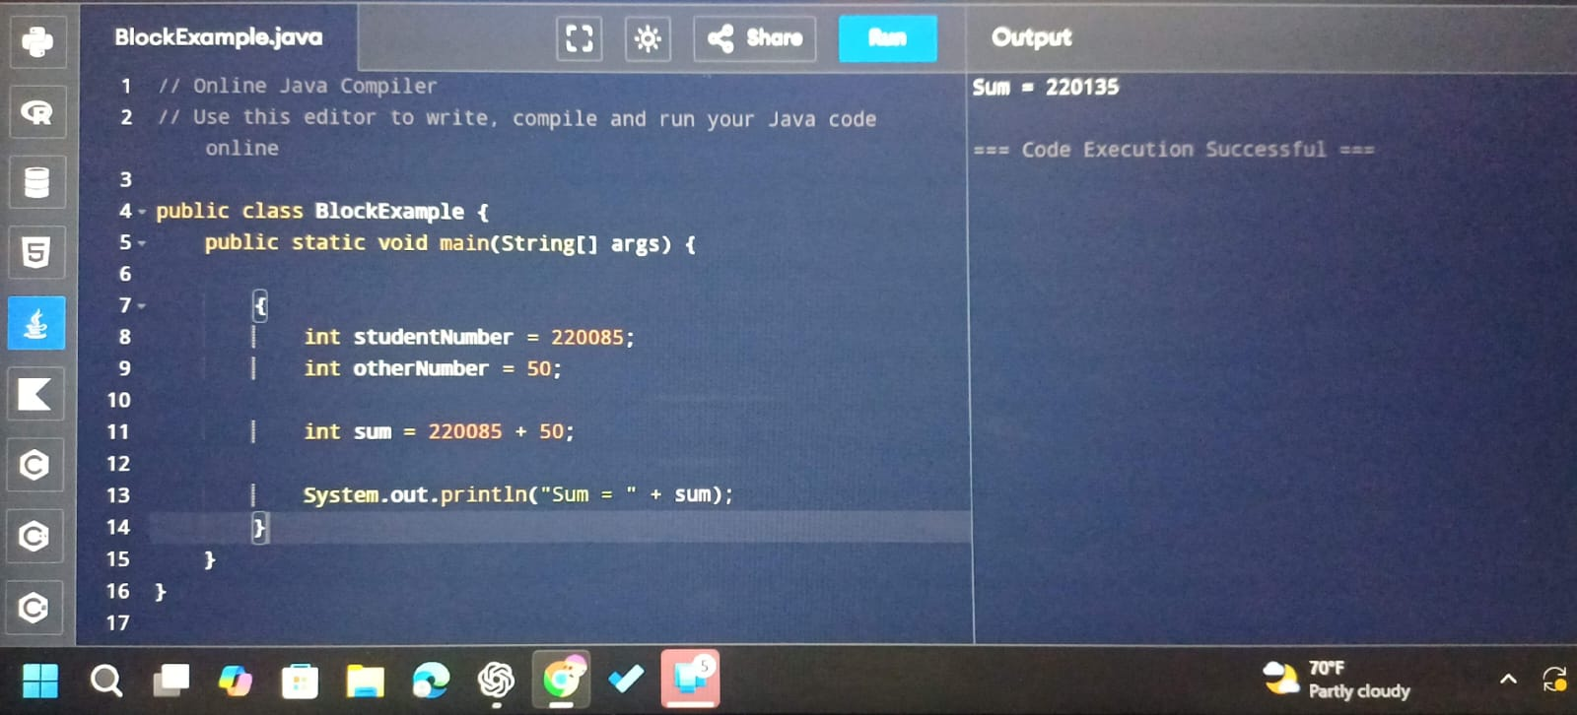

Question 2: If Statements
import java.util.Scanner;

public class Main{
public static void main(String[] args) {
Scanner input = new Scanner(System.in);

System.out.print("Enter feet: ");
int feet = input.nextInt();
System.out.print("Enter inches: ");
int inches = input.nextInt();
if (totalInches >= 6.0) {
System.out.println("Tall");
}
else if (totalInches >= 5.7 && < 6.0) {
System.out.println("Average");
}
else {
System.out.println("Short");
}
}
}
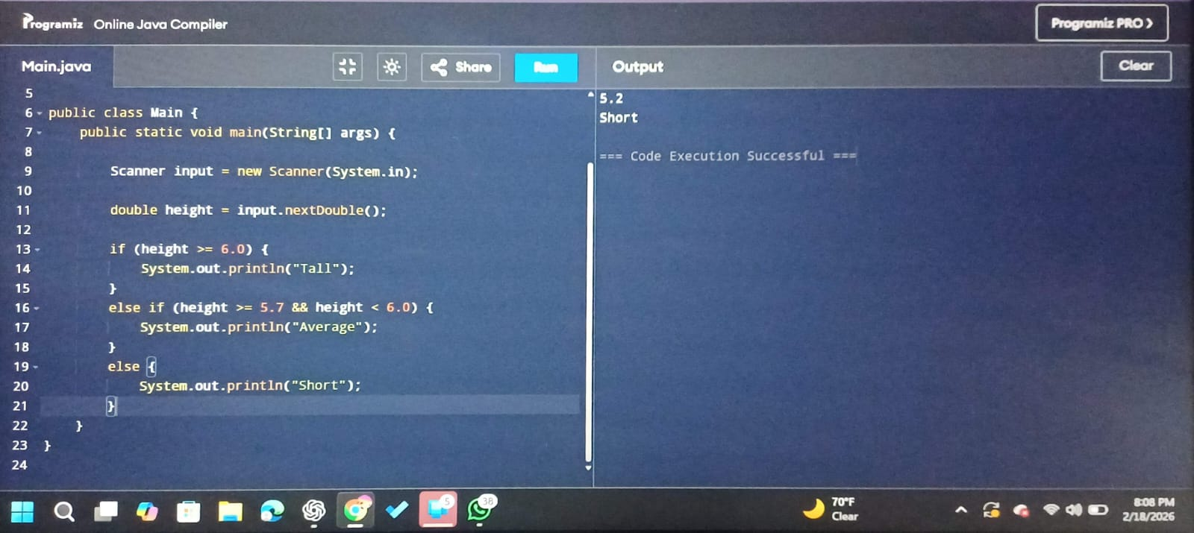

Question 3: Switch Statements
import java.util.Scanner;
public class DayOfWeek {
public static void main(String[] args) {
Scanner input = new Scanner(System.in);

System.out.print("Enter a number (1-7): ");
if (input.hasNextInt()) {
int day = input.nextInt();
switch (day) {
case 1 -> System.out.println("Monday");
case 2 -> System.out.println("Tuesday");
case 3 -> System.out.println("Wednesday");
case 4 -> System.out.println("Thursday");
case 5 -> System.out.println("Friday");
case 6 -> System.out.println("Saturday");
case 7 -> System.out.println("Sunday");
default -> System.out.println("Invalid input!");
}
} else {
System.out.println("Error: Please enter a whole number.");
}
}
}
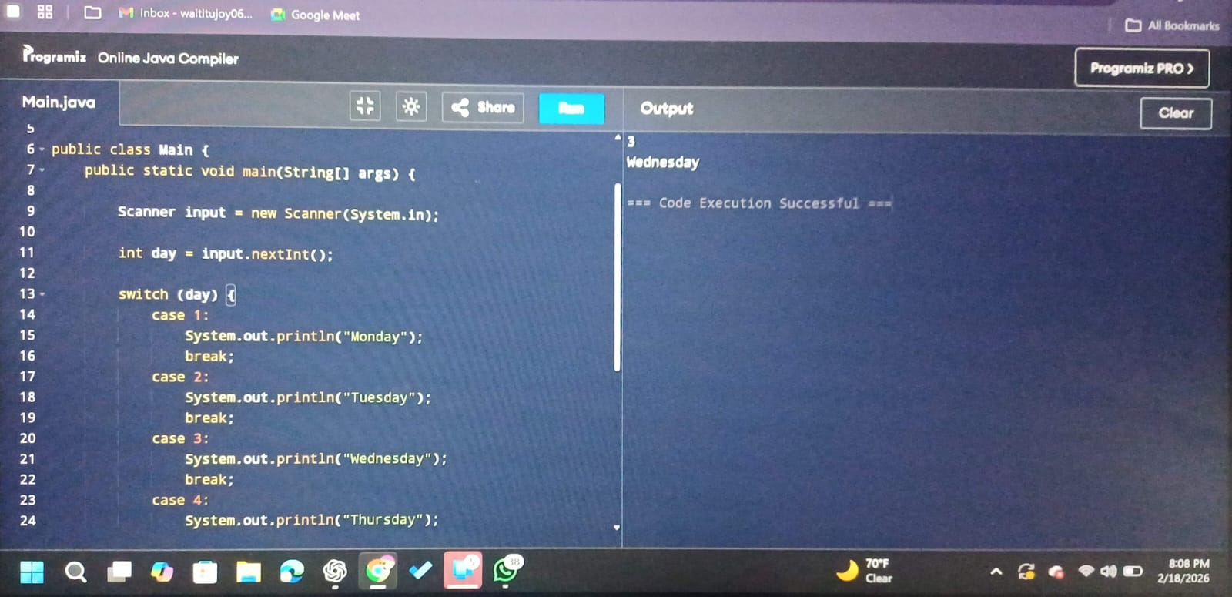

Question 4 : While Loop
import java.util.Scanner;

public class WhileExample {
public static void main(String[] args) {
Scanner input = new Scanner(System.in);

System.out.print("Enter a positive number: ");
if (input.hasNextInt()) {
int number = input.nextInt();
if (number < 1) {
System.out.println("Please enter a number 1 or greater.");
} else {
int counter = 1;
while (counter <= number) {
System.out.println(counter);
counter++;
}
}
} else {
System.out.println("Invalid input. Please enter a whole number.");
}
}
}
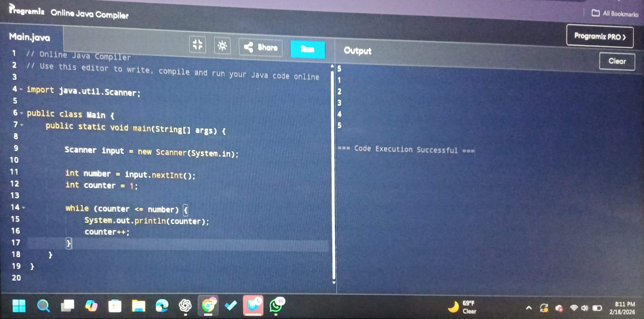

Question 5: Do While Loop
import java.util.Scanner;

public class Main{
public static void main(String[] args) {
Scanner input = new Scanner(System.in);

int correctStudentNumber = 220085;
String correctPassword = "java123";

int studentNumber;
String password;

do {
System.out.print("Enter student number: ");
if (input.hasNextInt()) {
int studentNumber = input.nextInt();

System.out.print("Enter password: ");
String password = input.next();

if (studentNumber == correctStudentNumber && password.equals(correctPassword)) {
System.out.println("Access Granted");
authenticated = true;
} else {
System.out.println("Incorrect details. Try again.");
}
} else {
System.out.println("Invalid student number format. Try again.");
input.next();
}
}
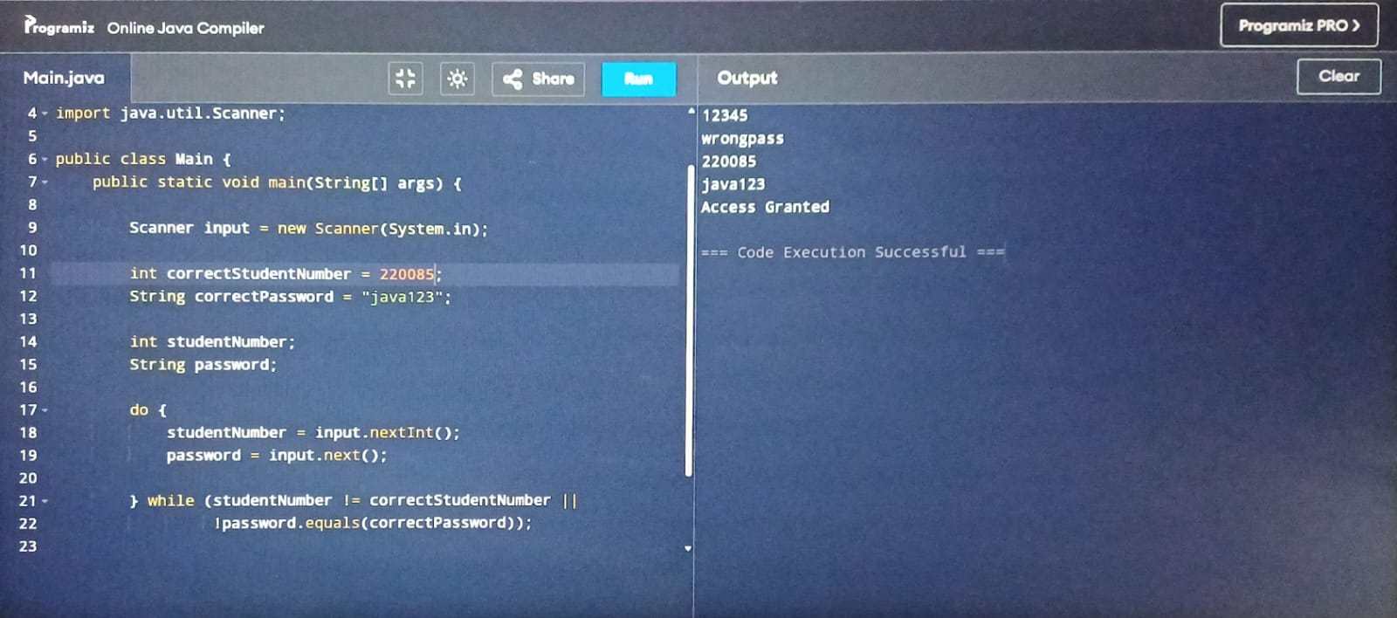

Question 6 : For Loop
import java.util.Scanner;

public class Main{
public static void main(String[] args) {
Scanner input = new Scanner(System.in);
int number = input.nextInt();

for (int i = number; i >= 0; i--) {
for (int j = i; j >= 0; j--) {
System.out.print(j);
}
System.out.println();

}
}
}
